physioSim: An Open-Source Framework for Benchmarking Statistical Methods for Physiological Time-Series Data

Jenna Lu
Department of Statistics
University of Florida
Corresponding author: Jenna Lu
Email: jenna.lu@ufl.edu

physioSim: An Open-Source Framework for Benchmarking Statistical Methods for Physiological Time-Series Data

Abstract
Physiological signals, including heart rate, electrodermal activity, and neural measurements, are inherently dynamic processes that evolve continuously over time. However, many biomedical studies analyze these signals using simplified summary measures such as mean response, peak activation, or area-under-the-curve estimates. Although these approaches improve interpretability and reduce analytical complexity, they may discard important temporal information, obscure individual response variability, and influence statistical conclusions.

We introduce physioSim, an open-source simulation framework designed to evaluate statistical methodology for repeated-measures physiological time-series data. The framework generates physiologically plausible response trajectories by incorporating participant-level heterogeneity, dynamic response structures, temporal dependence, measurement noise, and missing observations. Unlike general-purpose longitudinal simulation frameworks, physioSim is specifically designed to represent physiologically realistic response patterns, including rapid activation, delayed responses, habituation, and sustained effects.

Using controlled simulation experiments, we demonstrate how physioSim can evaluate statistical performance metrics including statistical power, Type I error rates, parameter bias, and confidence interval coverage under controlled experimental conditions. As an initial validation experiment, we evaluate the performance of linear mixed-effects models for detecting simulated physiological condition effects and examine how sample size, temporal dependence, and missing observations influence statistical inference. In validation experiments, linear mixed-effects models recovered unbiased condition effects but exhibited reduced confidence interval coverage when temporal dependence was present but unmodeled, demonstrating the ability of physioSim to identify limitations of conventional analytical approaches.

Across repeated simulations, we demonstrate how physioSim can quantify statistical performance metrics including statistical power, Type I error rates, parameter bias, and confidence interval coverage under controlled experimental conditions. The results demonstrate that physioSim provides a flexible and reproducible platform for investigating when traditional statistical approaches remain reliable and when trajectory-based methods provide improved inference for complex physiological signals.

Author Summary
In this study, I developed physioSim to investigate a common challenge in physiological data analysis: continuous biological signals are often reduced to a single summary measure before statistical analysis. While measures such as mean response or peak activation are easy to interpret, they can discard important temporal information. I created an open-source simulation framework that generates physiologically plausible response trajectories incorporating participant variability, temporal autocorrelation, measurement noise, and missing observations. Using this framework, I compared summary-statistic models, linear mixed-effects models, and generalized additive models. The simulations showed that statistical performance depends strongly on the underlying physiological response pattern. I hope physioSim will provide researchers with an accessible tool for evaluating statistical methods and selecting analyses that better capture the complexity of physiological time-series data.

Keywords
physiological time-series; simulation study; mixed-effects models; generalized additive models; statistical methodology; reproducible research

Introduction
Physiological measurements capture continuously evolving biological processes that exhibit both within-subject temporal dynamics and between-subject variability. Signals such as heart rate, electrodermal activity, and other psychophysiological measures are widely used to characterize biological responses during experimental and clinical studies (Allen, 2007; Cacioppo et al., 2007). Heart-rate responses to experimental stimuli, for example, may exhibit rapid activation, delayed responses, habituation, or sustained physiological changes over time. These temporal response patterns are often central to understanding biological mechanisms but may not be adequately represented by single summary measures.

Despite the temporal structure of physiological signals, many biomedical analyses reduce repeated measurements into simplified features such as mean response, maximum response, or area under the curve. Although these summaries simplify analysis and improve interpretability, they may discard important temporal information contained within physiological trajectories (Allen, 2007; Cacioppo et al., 2007).

These challenges are particularly important in repeated-measures experimental designs, where observations collected from the same participant are correlated over time and require statistical methods that account for within-subject dependence (Laird & Ware, 1982; Pinheiro & Bates, 2000). Physiological datasets frequently exhibit temporal autocorrelation, irregular sampling, missing observations, and substantial heterogeneity in response trajectories. Ignoring these characteristics may lead to underestimated uncertainty, inflated Type I error rates, or reduced statistical power.

Simulation studies provide an important framework for evaluating statistical performance because the underlying data-generating mechanism is known. By controlling characteristics of simulated datasets, researchers can systematically evaluate statistical methods under predefined experimental conditions (Burton et al., 2006; Morris et al., 2019). However, many existing simulation frameworks focus on general longitudinal data structures and do not incorporate realistic physiological response dynamics, such as delayed activation, habituation, and sustained physiological responses. To address this gap, we developed physioSim, an open-source simulation framework for generating physiological time-series data and benchmarking statistical methods under controlled experimental conditions. Unlike general longitudinal simulation frameworks, physioSim was developed specifically to emulate physiologically plausible response trajectories, including immediate activation, delayed responses, habituation, and sustained effects, allowing systematic benchmarking of statistical methods across realistic biological scenarios.

By enabling systematic evaluation under known data-generating mechanisms, physioSim provides a reproducible platform for understanding how characteristics of physiological time-series data influence statistical inference. Specifically, this study had four objectives: (1) to develop a flexible simulation framework for repeated-measures physiological time-series data; (2) to incorporate physiologically motivated response trajectories, participant-level heterogeneity, temporal dependence, measurement noise, and missing observations into a modular simulation architecture; (3) to evaluate the statistical performance of commonly used analytical approaches under controlled simulation conditions; and (4) to provide an open and reproducible software framework for future methodological benchmarking studies.

Materials and Methods

Simulation Framework
The physioSim framework generates repeated-measures physiological time-series data through a modular simulation pipeline consisting of six sequential components: participant generation, physiological response trajectory generation, measurement noise generation, temporal dependence modeling, missing-data simulation, and statistical model evaluation. Because each component is implemented independently, investigators can modify individual aspects of the data-generating mechanism without altering the remainder of the simulation pipeline.

For participant $i$observed at time point $t$, the simulated physiological measurement is denoted by
$$Y_{it}$$
where $i$indexes participants and $t$indexes repeated measurement occasions.

The modular architecture allows individual components of the physiological data-generating process to be modified independently, enabling systematic evaluation of how specific characteristics influence statistical inference.

The simulated physiological outcome was generated according to the hierarchical model
$$Y_{it}=μ+f\left(t , Condition_{i}\right)+b_{i}+ϵ_{it}$$
where μ denotes the overall baseline mean, $f\left(t , Condition\right)$represents the condition-specific physiological response trajectory over time, $b_{i}$is a participant-specific random intercept capturing between-subject variability, and $ε_{it}$denotes temporally correlated measurement error.

All simulations were implemented in R (version 4.3.2) using reproducible random-number generation with a fixed random seed. The modular implementation allows simulation parameters, including sample size, effect size, temporal autocorrelation, measurement noise, and missing-data mechanisms, to be modified independently for benchmarking studies.

The trajectory component $f\left(t\right)$was modified across experimental conditions to generate distinct physiological response patterns including immediate activation, delayed activation, habituation, sustained response, and null effects.

Different physiological response patterns were generated by modifying only the trajectory function $f\left(t , Condition\right)$, while holding the remaining simulation components constant. This design allowed individual characteristics of the physiological response to be evaluated independently.

Representative simulated physiological response trajectories are shown in Figure 1.

Examples of simulated physiological trajectories representing null, immediate, delayed, habituating, and sustained response patterns. The response functions demonstrate the ability of physioSim to generate diverse temporal structures commonly observed in physiological experiments.

Data-Generating Model
The simulated physiological outcome for participant $i$at measurement occasion $t$was generated according to the hierarchical model
$$Y_{it}=μ+f\left(t , {Condition}_{i}\right)+b_{i}+ϵ_{it},$$
where $Y_{it}$denotes the observed physiological measurement for participant $i$at time point $t$.
The parameter $μ$represents the overall baseline mean physiological response shared across participants before condition-specific effects are introduced. This parameter establishes the reference level from which individual trajectories evolve and can be modified to represent different baseline physiological states.

The function $f\left(t , {Condition}_{i}\right)$defines the expected physiological response trajectory over time for each experimental condition. This component governs the temporal shape of the simulated response and is responsible for generating physiologically plausible patterns such as immediate activation, delayed activation, habituation, sustained responses, or null effects. Because the trajectory function is specified independently of the remaining model components, alternative response profiles can be evaluated without modifying other aspects of the data-generating process.

The participant-specific random effect $b_{i}$represents between-subject variability in baseline physiological response and accounts for natural differences among individuals. Random intercepts were sampled independently for each participant to produce heterogeneous baseline response levels commonly observed in physiological experiments.

The residual error term $ϵ_{it}$represents within-subject measurement variability after accounting for the expected physiological trajectory and participant-specific baseline differences. To reflect the temporal dependence characteristic of physiological time-series data, residual errors were generated using a first-order autoregressive [AR(1)] process. This structure allows observations collected closer together in time to exhibit greater correlation than observations separated by longer intervals while also incorporating random measurement noise.

Together, these model components provide a flexible hierarchical framework capable of generating realistic repeated-measures physiological datasets while allowing individual aspects of the data-generating mechanism to be modified independently for simulation studies.

Participant Generation
To represent natural physiological variability between individuals, physioSim incorporates participant-specific random effects into the hierarchical data-generating model. These random effects account for baseline differences among participants that are commonly observed in repeated-measures physiological studies.

Participant-specific random intercepts were generated as
$$b_{i}∼N\left(0 , σ_{b}^{2}\right),$$
where $b_{i}$denotes the deviation of participant $i$from the overall population baseline and $σ_{b}^{2}$represents the between-subject variance. The random intercept $b_{i}$is incorporated into the full data-generating model,
$$Y_{it}=μ+f\left(t , {Condition}_{i}\right)+b_{i}+ϵ_{it},$$
thereby allowing each participant to follow the same underlying physiological response trajectory while maintaining an individual-specific baseline level.

Sampling participant-specific effects from a normal distribution produces heterogeneous physiological trajectories that more closely resemble experimental data than simulations assuming identical participants. The magnitude of the between-subject variance can be modified to investigate how individual heterogeneity influences statistical power, parameter estimation, confidence interval coverage, and other performance metrics across competing statistical methods.

This hierarchical random-effects formulation is consistent with established approaches for modeling correlated repeated-measures data in longitudinal studies (Laird & Ware, 1982; Pinheiro & Bates, 2000).

Physiological Response Trajectory Generation
The primary source of variation across simulation scenarios was the condition-specific physiological response trajectory, represented by the function $f\left(t , {Condition}_{i}\right)$in the hierarchical data-generating model. This component determines the expected physiological response over time and provides the flexibility to generate a wide range of temporal patterns commonly observed in experimental and clinical physiology.

The physioSim framework supports multiple response profiles designed to emulate distinct physiological processes, including null responses, immediate activation, delayed activation, habituation, and sustained activation. A null response represents the absence of a condition effect, whereas immediate activation produces an abrupt physiological change immediately following stimulus onset. Delayed activation introduces a latency period before the response emerges, reflecting biological processes that develop gradually over time. Habituation responses exhibit an initial increase followed by progressive attenuation, while sustained activation maintains an elevated response throughout the observation period.

For each simulation scenario, the trajectory function was modified while all remaining components of the data-generating model, including participant-specific variability, residual error, and temporal dependence, were held constant. This design isolates the influence of temporal response structure on statistical performance and enables direct comparison of analytical methods under controlled experimental conditions.

Representative examples of the simulated physiological response trajectories are presented in Figure 1.

Residual Error and Temporal Dependence
Physiological measurements collected repeatedly from the same participant are typically correlated over time, violating the assumption of independent observations commonly required by standard statistical models. To generate realistic within-subject dependence, physioSim models the residual error term using a first-order autoregressive [AR(1)] process.

For participant $i$, the residual errors were generated according to
$$ϵ_{it}=ρ ϵ_{i,t-1}+η_{it},$$
where $ρ$is the autoregressive parameter governing the strength of temporal correlation, and
$$η_{it}∼N\left(0 , σ_{η}^{2}\right)$$
represents independent measurement noise. Values of $ρ$close to zero produce approximately independent observations, whereas larger positive values generate increasingly persistent temporal dependence between successive measurements.

The AR(1) structure reflects a common characteristic of physiological time-series data, in which observations recorded close together in time are more strongly correlated than observations separated by longer intervals (Box et al., 2015). By varying the autoregressive parameter across simulation scenarios, physioSim enables systematic investigation of how temporal dependence influences parameter estimation, statistical power, confidence interval coverage, and hypothesis testing while holding other components of the data-generating process constant.

Missing Data Simulation

Missing observations are common in physiological time-series data owing to sensor failure, motion artifacts, signal corruption, and quality-control procedures. Because incomplete observations can influence statistical estimation and inference, physioSim incorporates controlled missing-data mechanisms to evaluate the robustness of statistical methods under varying levels of data loss.

In the current study, missing values were introduced under a missing completely at random (MCAR) mechanism at proportions ranging from 0% to 40% of the simulated observations. Under the MCAR assumption, the probability that an observation is missing is independent of both observed and unobserved data, allowing the effects of missingness to be evaluated without introducing systematic bias.

The proportion of missing observations was varied across simulation experiments while all other components of the data-generating process were held constant. This design enabled systematic investigation of how increasing levels of missing data influence statistical power, parameter estimation, confidence interval coverage, and other measures of inferential performance.

Statistical Model Evaluation
The primary objective of physioSim is to provide a flexible framework for benchmarking statistical methods commonly used to analyze repeated-measures physiological data. Because the underlying data-generating mechanism is known, simulated datasets provide an objective basis for evaluating statistical performance under controlled experimental conditions.

The framework supports multiple analytical approaches, including summary-statistic models, linear mixed-effects models, and generalized additive models. Summary-statistic approaches reduce repeated measurements to participant-level features, such as mean response or peak activation, before statistical analysis. Linear mixed-effects models account for both fixed effects and participant-specific random effects while accommodating the correlation induced by repeated observations (Laird & Ware, 1982; Pinheiro & Bates, 2000). Generalized additive models extend regression by incorporating smooth functions of time, allowing flexible modeling of nonlinear physiological response trajectories (Hastie & Tibshirani, 1990; Wood, 2017).

As an initial validation of the simulation framework, statistical performance was evaluated using linear mixed-effects models. For participant $i$at measurement occasion $t$, the fitted model was
$$Y_{it}=β_{0}+β_{1}{Condition}_{it}+β_{2}{Time}_{it}+b_{i}+ϵ_{it},$$
where $β_{0}$represents the fixed intercept, $β_{1}$estimates the condition effect, $β_{2}$represents the effect of time, $b_{i}$is a participant-specific random intercept, and $ϵ_{it}$denotes the residual error.

For each simulation scenario, statistical power was estimated as the proportion of simulation replicates in which the condition effect was detected using a two-sided significance level of $α=0.05$. Unless otherwise stated, each experimental condition was evaluated using 200 independent simulation replicates.

Simulation Experiments
To demonstrate the capabilities of the physioSim framework, a series of simulation experiments was conducted to evaluate statistical inference under controlled physiological time-series conditions. Because the underlying data-generating mechanism was known, statistical performance could be assessed objectively by comparing estimated parameters and inferential outcomes with their true simulated values.

The initial validation experiment evaluated the relationship between participant sample size and statistical power for detecting simulated physiological responses using linear mixed-effects models. This experiment assessed whether physioSim reproduced expected statistical behavior under increasing sample sizes.

Physiological datasets were simulated across a range of participant sample sizes while maintaining identical response trajectories, between-subject variability, temporal dependence, and measurement noise. For each sample-size condition, independent simulation replicates were generated using a fixed random seed to ensure reproducibility. Each simulated dataset was analyzed using the linear mixed-effects model described previously.

Statistical power was estimated as the proportion of simulation replicates in which the simulated condition effect was detected using a two-sided significance level of α = 0.05. Additional simulation experiments evaluated the influence of temporal autocorrelation and missing observations on statistical inference by varying these characteristics while holding all other components of the data-generating mechanism constant.

The modular design of physioSim allows future benchmarking studies to extend these experiments by incorporating additional physiological response trajectories, alternative statistical models, more complex missing-data mechanisms, and other sources of uncertainty.

Simulation Study: Benchmarking Statistical Methods Across Physiological Response Patterns
Simulation Design
To demonstrate the capabilities of physioSim, a simulation study was conducted to evaluate the performance of statistical methods across multiple physiological response patterns generated under a known data-generating mechanism. Because the true model parameters were known, statistical performance could be evaluated objectively by comparing each analytical approach under identical experimental conditions.

The benchmarking study considered five representative physiological response patterns: null response, immediate activation, delayed activation, habituation, and sustained activation. These response profiles were selected to represent a range of temporal dynamics commonly observed in experimental physiology while maintaining identical participant-level variability, temporal dependence, and measurement noise across simulation scenarios.

Each simulated dataset consisted of repeated heart-rate measurements collected under baseline and cue conditions. Unless otherwise specified, simulation parameters were held constant across experiments so that differences in statistical performance could be attributed solely to the underlying physiological response pattern.

Table 1. Simulation parameters used for statistical method benchmarking.
Parameter | Value
Sample size | 80 participants
Physiological response patterns | Null, immediate activation, delayed activation, habituation, sustained activation
Effect amplitude | 3 beats/min
Temporal autocorrelation | $$ρ=0.60$$
Measurement noise | $σ=4$beats/min
Simulation replicates | 200
Significance level | $$α=0.05$$

For each response pattern, 200 independent datasets were generated using identical simulation settings except for the trajectory function defining the temporal response. This design enabled systematic evaluation of how temporal response structure influences statistical inference while controlling all other aspects of the data-generating process.

Statistical Models
Each simulated dataset was analyzed using three statistical approaches commonly employed for repeated-measures physiological data analysis. These methods were selected because they differ substantially in their ability to represent temporal response structure while reflecting analytical approaches frequently used in biomedical and psychophysiological research.

The summary-statistic approach reduced each participant's repeated observations to a single condition-specific summary measure prior to analysis. These participant-level summaries were subsequently analyzed using ordinary linear regression.

Linear mixed-effects models incorporated both fixed effects and participant-specific random intercepts to account for the correlation induced by repeated observations (Laird & Ware, 1982; Pinheiro & Bates, 2000). Generalized additive models extended this framework by incorporating smooth functions of time, allowing flexible estimation of nonlinear physiological response trajectories (Hastie & Tibshirani, 1990; Wood, 2017).

All statistical methods were applied to identical simulated datasets generated under each experimental condition. This design ensured that differences in statistical performance reflected the analytical approach rather than differences in the underlying data-generating process.

Performance Metrics
Statistical performance was evaluated using four complementary metrics that quantify the ability of each analytical method to detect simulated physiological responses while providing accurate statistical inference.

Statistical power was defined as the probability of correctly detecting a true physiological response when a condition effect was present. Across simulation replicates, power was estimated as
$$\text{Power}=P\left(p<0.05∣β_{1}≠0\right),$$
where $β_{1}$denotes the true condition effect and statistical significance was evaluated using a two-sided significance level of $α=0.05$.

Type I error rate was evaluated under the null-response simulation scenario, in which no true condition effect was present. The Type I error rate was estimated as
$$\text{Type I Error}=P\left(p<0.05∣β_{1}=0\right),$$
representing the probability of incorrectly rejecting the null hypothesis.

Parameter bias was used to assess the accuracy of effect-size estimation and was calculated as
$$\text{Bias}={\overline{β}}_{1}-β_{1},$$
where ${\overline{β}}_{1}$is the average estimated condition effect across simulation replicates and $β_{1}$is the true simulated effect. Values closer to zero indicate more accurate parameter estimation.

Confidence interval coverage was defined as the proportion of simulation replicates in which the estimated confidence interval contained the true parameter value. Coverage probability was estimated as
$$\text{Coverage}=P\left(β_{1}∈CI\right),$$
where $CI$denotes the estimated confidence interval for the condition effect. Confidence interval coverage provides an assessment of whether model-based uncertainty is appropriately calibrated across repeated simulations.

Together, these performance metrics provide a comprehensive assessment of statistical inference by evaluating detection capability, false-positive control, estimation accuracy, and uncertainty quantification under controlled simulation conditions.

Results
Validation of Physiological Trajectory Generation
Figure 1 illustrates representative physiological response trajectories generated by the physioSim framework. The simulated data reproduced five distinct temporal response patterns commonly observed in physiological experiments: null response, immediate activation, delayed activation, habituation, and sustained activation. Although all response patterns were generated using the same hierarchical data-generating framework, modification of the trajectory function $f\left(t , Condition\right)$produced substantially different temporal dynamics while preserving participant-level variability, measurement noise, and temporal dependence.

The simulated trajectories demonstrate the ability of physioSim to generate physiologically plausible time-series data under controlled experimental conditions. Because the underlying response function is known, these simulations provide an objective foundation for evaluating statistical methods and determining how different temporal response structures influence statistical inference.

Figure 1. Representative physiological response trajectories generated by physioSim. Simulated response patterns include null response, immediate activation, delayed activation, habituation, and sustained activation. All trajectories were generated using the same hierarchical simulation framework while varying only the condition-specific trajectory function.

Statistical Performance of Linear Mixed-Effects Models
The initial validation experiment evaluated the performance of linear mixed-effects models for detecting simulated physiological condition effects across increasing participant sample sizes. Statistical power increased with both participant sample size and simulated effect magnitude (Figure 2). Larger physiological effects produced greater statistical sensitivity across all sample sizes, whereas smaller effects required substantially larger samples to achieve comparable power. These results demonstrate that physioSim reproduces expected relationships between experimental design characteristics and statistical performance.

These findings provide an initial validation of the simulation framework by showing that simulated physiological datasets reproduce established statistical behavior under controlled experimental conditions. As sample size increased, the probability of detecting the simulated condition effect improved, demonstrating that the framework can generate datasets with realistic relationships between study design characteristics and statistical performance.

Although the current evaluation focused on linear mixed-effects models, the modular architecture of physioSim allows future benchmarking of additional analytical approaches, including summary-statistic models, generalized additive models, and trajectory-based methods. Because data generation and statistical analysis are separated within the framework, alternative statistical models can be incorporated without modifying the underlying simulation pipeline.

Figure 2. Statistical power of linear mixed-effects models across increasing sample sizes. Statistical power for detecting simulated physiological condition effects using linear mixed-effects models across increasing participant sample sizes. Each point represents 200 independent simulation replicates. Increasing sample size resulted in improved statistical power, demonstrating that physioSim reproduces expected relationships between sample size and inferential sensitivity.

Parameter Recovery and Confidence Interval Coverage
Parameter recovery was evaluated by comparing estimated condition effects from simulation replicates with the true simulated effect of 3 bpm. Table 2 summarizes the mean estimated effect, parameter bias, standard deviation (SD), root mean squared error (RMSE), and empirical confidence interval coverage across increasing sample sizes.

Across all simulation scenarios, the linear mixed-effects model recovered the true condition effect with minimal bias. Mean estimated effects ranged from 2.99 to 3.02 bpm, with absolute bias remaining below 0.02 bpm across all sample sizes. Estimation precision improved with increasing sample size, as reflected by reductions in standard deviation and RMSE. RMSE decreased from 0.824 bpm at $n=20$to 0.280 bpm at $n=160$, indicating improved parameter precision with larger sample sizes.

Despite accurate point estimation, empirical confidence interval coverage remained substantially below the nominal 95% level, ranging from 69.8% to 75.0% across simulation conditions. Because temporal autocorrelation was incorporated during data generation but was not explicitly modeled during estimation, the reduced coverage indicates that ignoring temporal dependence can result in underestimated uncertainty even when estimated effects remain unbiased.

Together, these findings demonstrate that physioSim can evaluate not only statistical power and parameter recovery but also the ability of analytical methods to provide appropriately calibrated uncertainty estimates under realistic physiological time-series conditions.

Table 2. Parameter recovery and confidence interval coverage across simulated sample sizes.
Sample size | Mean estimate | Bias | SD | RMSE | Coverage
20 | 3.00 | 0.003 | 0.467 | 0.824 | 0.698
40 | 2.99 | -0.012 | 0.312 | 0.539 | 0.750
80 | 3.02 | 0.016 | 0.239 | 0.398 | 0.738
160 | 3.01 | 0.014 | 0.161 | 0.280 | 0.740

Effect of Temporal Dependence on Statistical Inference
To evaluate the influence of temporal dependence on statistical inference, additional simulations were conducted across increasing levels of autoregressive correlation while holding all other simulation parameters constant. Figure 3 summarizes empirical Type I error rates under the null-response condition.

As temporal autocorrelation increased, empirical Type I error rates increasingly deviated from the nominal significance level of $α=0.05$. These results demonstrate that unmodeled temporal dependence can adversely affect statistical inference by increasing false-positive rates when correlated physiological observations are analyzed using models that do not adequately account for within-subject dependence.

The ability to reproduce these effects highlights the importance of incorporating realistic temporal structures into simulation frameworks for physiological time-series analysis. By allowing temporal dependence to be controlled independently, physioSim provides a mechanism for evaluating how analytical assumptions influence statistical performance.

Figure 3. Type I error rates under increasing temporal autocorrelation. Empirical false-positive rates of linear mixed-effects models under increasing levels of autoregressive dependence. The dashed horizontal line represents the nominal significance level of $α=0.05$. Results demonstrate the influence of correlated physiological observations on statistical inference.

Effect of Missing Observations on Statistical Power
To evaluate robustness under incomplete physiological measurements, additional simulations examined statistical power across increasing proportions of missing observations while holding all other simulation parameters constant. Figure 4 summarizes the statistical power of linear mixed-effects models under each missing-data condition.

Statistical power decreased progressively as missing observations increased, reflecting the reduction in available information for estimating the simulated condition effect. These results demonstrate that physioSim can quantify the influence of incomplete physiological measurements on statistical sensitivity while maintaining control over the underlying data-generating mechanism.

By incorporating controlled missing-data mechanisms, physioSim provides a framework for evaluating how data quality limitations influence statistical conclusions and for comparing analytical strategies under realistic physiological measurement conditions.

Figure 4. Statistical power under increasing levels of missing physiological observations. Statistical power of linear mixed-effects models under increasing proportions of missing observations. All other simulation parameters were held constant, allowing the effect of incomplete physiological measurements on statistical sensitivity to be evaluated.

Discussion
Simulation studies provide a rigorous framework for evaluating statistical methodology because the underlying data-generating mechanism is known, allowing statistical performance to be assessed under controlled experimental conditions (Morris et al., 2019). In this study, we introduced physioSim, an open-source simulation framework designed specifically for benchmarking statistical methods applied to repeated-measures physiological time-series data. Unlike general longitudinal simulation frameworks, physioSim incorporates physiologically motivated response trajectories, participant-level heterogeneity, temporal dependence, measurement noise, and missing observations within a modular and reproducible simulation pipeline.

The initial validation experiments demonstrated that statistical performance depends strongly on the characteristics of the underlying physiological data-generating process. Linear mixed-effects models produced nearly unbiased estimates of simulated condition effects; however, empirical confidence interval coverage was reduced when temporal autocorrelation was present but not explicitly modeled. These findings highlight the importance of evaluating not only point estimation accuracy but also uncertainty quantification when analyzing physiological time-series data.

The simulation framework was designed to support broader methodological comparisons in future work. Because physioSim separates trajectory generation, data corruption mechanisms, and statistical evaluation components, researchers can incorporate alternative analytical approaches and systematically examine when different modeling strategies provide reliable inference under specific physiological conditions.

An additional contribution of the simulation framework is its ability to evaluate the quality of statistical inference beyond hypothesis testing alone. Although the linear mixed-effects model produced nearly unbiased estimates of the simulated condition effect, empirical confidence interval coverage remained substantially below the nominal 95% level. Because temporal autocorrelation was incorporated during data generation but not explicitly modeled during estimation, these findings demonstrate how simulation studies can identify situations in which conventional statistical models provide accurate point estimates while underestimating statistical uncertainty. Such evaluations are difficult or impossible to perform using empirical datasets, where the true underlying parameters are unknown.

Limitations
The present study represents an initial demonstration of the physioSim framework and has several limitations. First, the validation experiments focused primarily on heart-rate trajectories and a limited set of representative physiological response patterns. Although the modular framework can be readily extended to additional physiological signals, including electrodermal activity, respiration, electromyography, and electroencephalography, these modalities were not evaluated in the current study. Second, missing observations were simulated under a missing completely at random (MCAR) mechanism, whereas real physiological datasets frequently exhibit more complex missing-data processes. Finally, the current benchmarking experiments considered a representative set of statistical models but do not encompass the full range of modern analytical approaches available for physiological time-series analysis.

Future work will extend physioSim by incorporating additional physiological response models, more complex missing-data mechanisms, alternative temporal dependence structures, and a broader range of statistical learning methods. Because the framework was designed with a modular architecture, new simulation components and analytical methods can be incorporated without modifying the underlying simulation pipeline, facilitating continued methodological development.

Conclusion
physioSim provides an open-source framework for evaluating statistical methods for physiological time-series data under controlled and reproducible simulation conditions. By incorporating dynamic response trajectories, participant-level heterogeneity, temporal dependence, measurement noise, and missing observations, the framework enables systematic investigation of how physiological data characteristics influence statistical inference.
The simulation experiments demonstrate that statistical performance depends not only on sample size and effect magnitude but also on the temporal structure of physiological responses and the assumptions underlying analytical models. By providing a flexible platform for generating physiologically plausible response trajectories and benchmarking statistical approaches, physioSim supports more rigorous evaluation of methodological choices in biomedical and behavioral research.
Future extensions of physioSim will incorporate additional physiological modalities, more complex missing-data mechanisms, and expanded statistical modeling approaches. The framework is intended to facilitate reproducible methodological research and improve the development and selection of statistical tools for analyzing complex physiological time-series data.

Ethical Considerations
This study used simulated data exclusively and did not involve human participants, animal subjects, or identifiable personal information. Consequently, institutional review board approval was not required.

Code and Data Availability
The physioSim framework was implemented in R using a modular architecture that separates data generation, statistical model fitting, and performance evaluation. The framework is designed to facilitate reproducible simulation studies by allowing individual components of the data-generating process, including participant generation, physiological response trajectories, temporal dependence, measurement noise, missing-data mechanisms, and statistical model evaluation, to be modified independently.

Open and reproducible computational workflows improve transparency, facilitate independent validation, and support methodological development (Peng, 2011). The physioSim source code, simulation scripts, and analysis pipeline are publicly available through the project's GitHub repository: https://github.com/jen-h-lu/physioSim

Because this study uses simulated data exclusively, no external human-subject dataset was analyzed. All simulated datasets used for the experiments, along with the code required to reproduce the reported figures and tables, are available through the repository.

Conflict of Interest
The author declares no conflicts of interest related to this work.

References
Allen, J. (2007). Photoplethysmography and its application in clinical physiological measurement. Physiological Measurement, 28(3), R1–R39. https://doi.org/10.1088/0967-3334/28/3/R01
Box, G. E. P., Jenkins, G. M., Reinsel, G. C., & Ljung, G. M. (2015). Time series analysis: Forecasting and control (5th ed.). Wiley.
Burton, A., Altman, D. G., Royston, P., & Holder, R. L. (2006). The design of simulation studies in medical statistics. Statistics in Medicine, 25(24), 4279–4292. https://doi.org/10.1002/sim.2673
Cacioppo, J. T., Tassinary, L. G., & Berntson, G. G. (Eds.). (2007). Handbook of psychophysiology (3rd ed.). Cambridge University Press.
Goldberger, A. L., Amaral, L. A. N., Glass, L., Hausdorff, J. M., Ivanov, P. C., Mark, R. G., Mietus, J. E., Moody, G. B., Peng, C.-K., & Stanley, H. E. (2000). PhysioBank, PhysioToolkit, and PhysioNet: Components of a new research resource for complex physiologic signals. Circulation, 101(23), e215–e220. https://doi.org/10.1161/01.CIR.101.23.e215
Hastie, T., & Tibshirani, R. (1990). Generalized additive models. Chapman & Hall.
Laird, N. M., & Ware, J. H. (1982). Random-effects models for longitudinal data. Biometrics, 38(4), 963–974.
Little, R. J. A., & Rubin, D. B. (2019). Statistical analysis with missing data (3rd ed.). Wiley.
Morris, T. P., White, I. R., & Crowther, M. J. (2019). Using simulation studies to evaluate statistical methods. Statistics in Medicine, 38(11), 2074–2102. https://doi.org/10.1002/sim.8086
Peng, R. D. (2011). Reproducible research in computational science. Science, 334(6060), 1226–1227. https://doi.org/10.1126/science.1213847
Pinheiro, J. C., & Bates, D. M. (2000). Mixed-effects models in S and S-PLUS. Springer.
R Core Team. (2023). R: A language and environment for statistical computing. R Foundation for Statistical Computing. https://www.R-project.org/
Ramsay, J. O., & Silverman, B. W. (2005). Functional data analysis (2nd ed.). Springer.
Wang, J.-L., Chiou, J.-M., & Müller, H.-G. (2016). Functional data analysis. Annual Review of Statistics and Its Application, 3, 257–295. https://doi.org/10.1146/annurev-statistics-041715-033624
Wood, S. N. (2017). Generalized additive models: An introduction with R (2nd ed.). Chapman & Hall/CRC.

Figure Captions
Figure 1. Representative physiological response trajectories generated by physioSim.
Thin lines represent individual simulated participant trajectories, and thicker lines represent population mean responses. Simulated response patterns include null response, immediate activation, delayed activation, habituation, and sustained activation. All trajectories were generated using the same hierarchical simulation framework while varying only the condition-specific trajectory function.

Figure 2. Statistical power of linear mixed-effects models across increasing sample sizes. Statistical power for detecting simulated physiological condition effects using linear mixed-effects models across increasing participant sample sizes. Each point represents the proportion of significant results across independent simulation replicates. Increasing sample size resulted in improved statistical power, demonstrating that physioSim reproduces expected relationships between sample size and inferential sensitivity.

Figure 3. Type I error rates under increasing temporal autocorrelation.
Empirical false-positive rates of linear mixed-effects models under increasing levels of temporal dependence. The dashed horizontal line represents the nominal significance level of $α=0.05$. Results demonstrate the influence of correlated physiological observations on statistical inference.

Figure 4. Statistical power under increasing levels of missing physiological observations. Statistical power of linear mixed-effects models under increasing proportions of missing observations. All other simulation parameters were held constant, allowing the effect of incomplete physiological measurements on statistical sensitivity to be evaluated.

Tables
Table 1. Simulation parameters used for statistical method benchmarking.
Table 2. Parameter recovery and confidence interval coverage across simulated sample sizes.

Figures
Figure 1
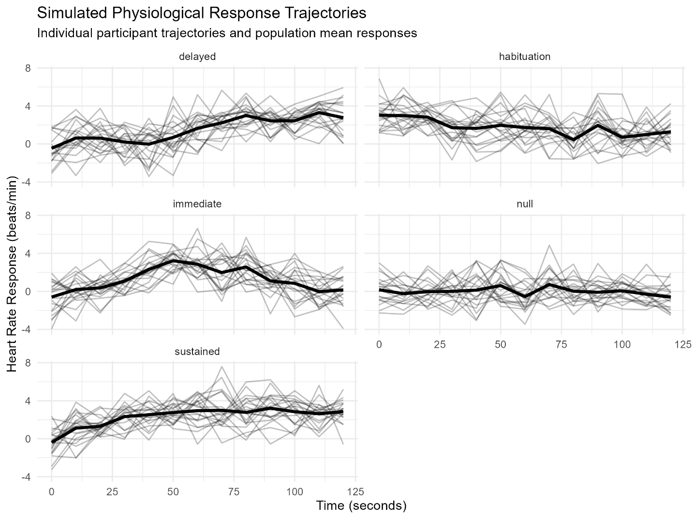

Figure 2
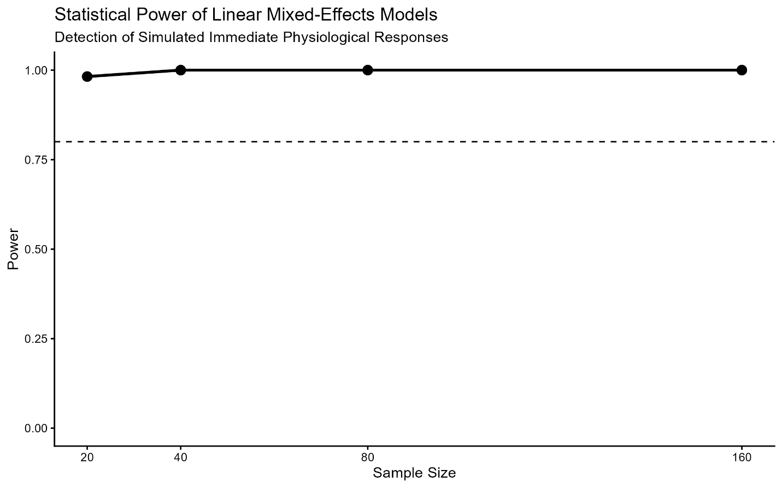

Figure 3
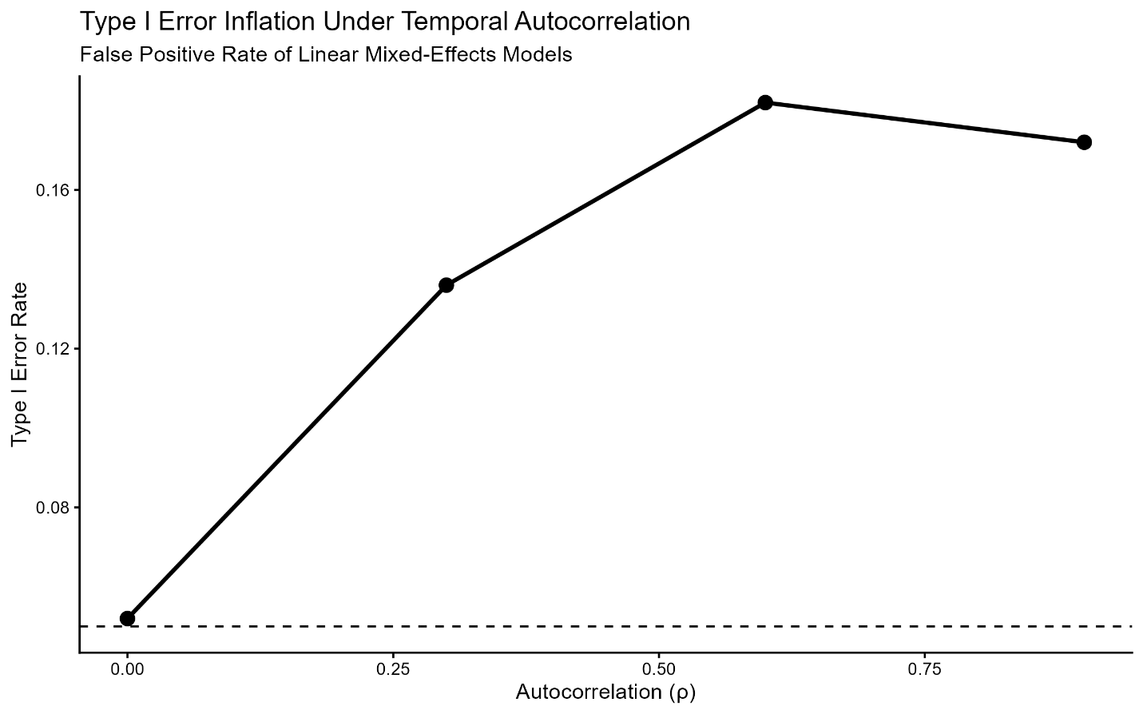

Figure 4
